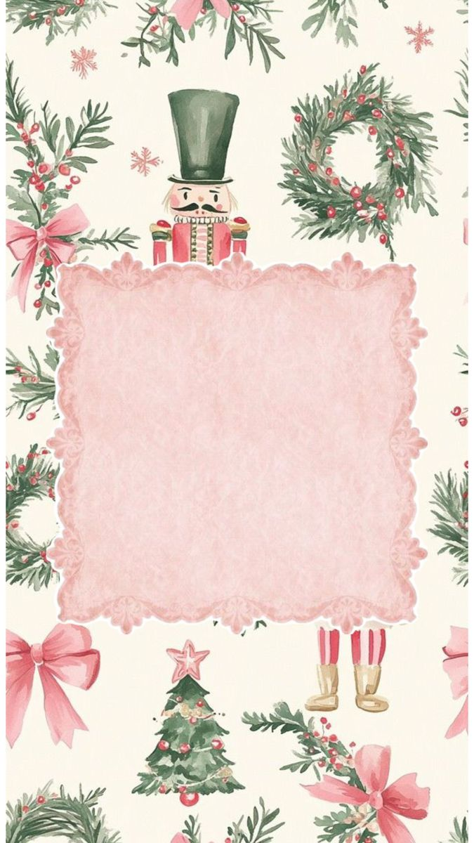
MERRY CHRISTMAS
May this Christmas bring your way plenty of reasons to smile I wish you and your family a very happy and joyous Christmas..!!!

